East Lothian Climate Action Network
‘Our Way of Working’ (Version OFFLINE - 1 March 2026)
Introduction 1
Why is this important? 1
Our Way of Working - ELCAN 1
1. Purpose of this document 1
2. Our sociocratic principles 2
3. Our circle structure 2
3.1 Mission Circle (the Board) 3
3.2 Staff Circle 4
3.3 Working Circles 4
4. Roles, membership and links 5
4.1 Membership of circles 5
4.2 Roles inside circles 5
4.3 Double linking and information flow 6
5. How we make decisions 6
5.1 Consent decision making 6
5.2 Delegation and autonomy 7
6. Meetings and communication 7
7. Review and development of this document 8
Some More Detail 8
Decentralised Authority 8
Double Linking 9
Process Roles required for each circle 9
Selection Process for Role-holders 10
Feedback 11
Transparency 11
Circle Membership 12
Routine Processes for Meetings 12
Record Keeping 13
Checking in at the start of a meeting 13
Consent to the Agenda 13
Using Rounds to draw people in 13
Proposals for decision 14
Understand, Explore, Decide 14
Consent process in rounds 14
Objections to Proposals 15
Range of tolerance 15
Meeting evaluation 16
Internal Communications 16

Introduction
We want to find creative ways of working together, which actively encourage diverse perspectives and thorough, honest deliberation, review, reflection and feedback. To this end, we are experimenting with Sociocracy as an approach to use for meeting processes and in creating a decentralised structure that disperses power and gives autonomy to those implementing the different aspects of ELCAN’s activity. This is a work in progress and will evolve over time as the network develops and we test out better ways of working together.

Why is this important?
- To ensure that ELCAN develops into a robust, resilient, agile and action focussed network in which decision making is devolved to those most closely involved in the various strands of ELCAN’s activity.
- To spread skills, knowledge and understanding across the ELCAN membership that can support and encourage better facilitation and the use of more participatory and deliberative approaches to decision making in their own organisations and communities.
- To ensure clarity and transparency about current ELCAN activity -what is happening and why, who is doing what and how to get involved.
- To ensure that the role of hub staff is to convene, support and facilitate network activity whilst participating equally with members in deciding ELCAN’s priorities for action.

Our Way of Working - ELCAN
ELCAN’s way of working is rooted in sociocratic principles, with clearly defined circles, shared responsibility, and consent-based decision making, while remaining light-touch and practical.

1. Purpose of this document
This “Our Way of Working” document explains the principles of how ELCAN is organised, how we make decisions, and how we work together in a sociocratic way. It is a living document that can be reviewed and adapted by consent as ELCAN’s operating context, priorities and membership change and develop.

2. Our sociocratic principles
The key principles of Sociocracy are very simple, providing a structured approach to sharing power and making decisions together. But whilst the principles are simple, the implementation is not always straightforward, dealing as we are with the complexities of human relationships and deeply embedded cultural norms around organisational structures and decision making.
Key principles
We commit to:
- Consent decision making: policies and major decisions are agreed when there are no remaining reasoned objections.
- Circles with clear domains: work is devolved/organised into circles (working groups), each with a clearly defined purpose, responsibilities, and authority.
- Linking and flow of information: circles are linked so information and influence move both ways between circles.
- Continuous learning: we review meetings and agreements regularly and try to improve our ways of working over time through honest feedback.

3. Our circle structure
ELCAN’s sociocratic circle structure is not yet fully formed. Currently there are the following: Mission Circle (the Board), Staff Team Circle, and Working Groups/Project Circles. We also plan to hold an annual ‘general assembly’ open to all members.
A possible future structure is outlined below:
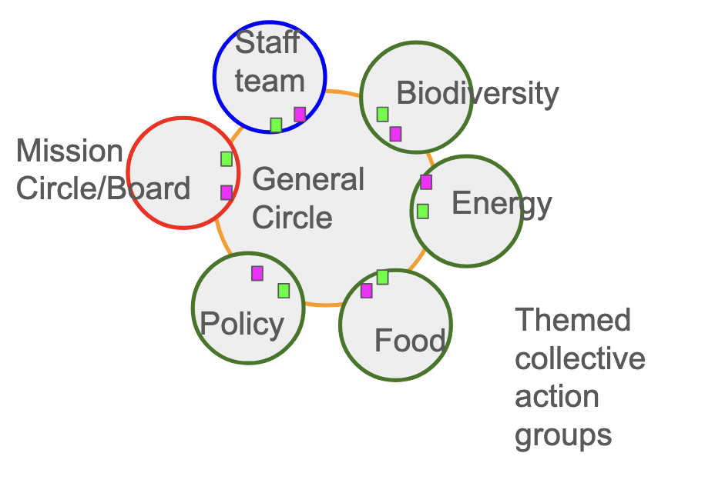

3.1 Mission Circle (the Board)
The Mission Circle is ELCAN’s Board and acts as the “mission holder” for the organisation. Once we become an independent SCIO, the board members will become charity trustees.
Its domain is:
- Holding ELCAN’s mission, vision and charitable purposes, and keeping us aligned with our values.
- Long-term strategy, major risks, and key relationships with funders, regulators, and external partners.
- Approving organisation-wide policies, budgets, and delegations to other circles.
- Responsibilities for employment, financial management and charitable governance.
The Mission Circle also currently functions as our ‘General Circle’, ensuring coordination between the activities of the Working Groups/Project Circles, including agreeing clear ‘domains’ and ‘circle profiles’ for each circle.
The Mission Circle works sociocratically by:
- Meeting regularly using a sociocratic meeting format, including opening check-ins, consent to agenda, content, and a closing/learning ‘check-out’ round.
- Making organisational policy decisions by consent in circle meetings.
- Including links from the Staff Circle and key Working Groups, so operational experience shapes strategic decisions.
- Inviting external people (for example, legal, financial or community expertise) when needed for advice and perspective.
- Making appropriate use of ‘rounds’ to ensure that all voices are heard

3.2 Staff Circle
The Staff Circle coordinates the day-to-day work of staff employed to deliver ELCAN’s programme.
Its domain is:
- Planning, prioritising, and reviewing delivery of projects and services within the agreed strategy and budget.
- Developing and implementing operational policies and processes (for example, staff collaboration, internal communications, volunteer support), within the strategic framework set by the Mission Circle.
- Supporting and liaising with Working Groups and member organisations, and ensuring good communication across the network.
The Staff Circle works sociocratically by:
- Meeting regularly using a sociocratic meeting format, including opening check-ins, consent to agenda, content, and a closing/learning ‘check-out’.
- Making decisions by consent on matters within its domain, and escalating only when decisions affect the domain of other circles or exceed delegated authority.
- Sending a double link (operational leader and elected representative) to Mission Circle meetings.
- Making appropriate use of ‘rounds’ to ensure that all voices are heard.

3.3 Working Circles
Working Groups (such as the Policy Circle, Biodiversity Collective and other thematic groups) are where much of the practical work and innovation happens.
Each Working Group is (or will become) a circle with its own aim, defined membership, and delegated authority. Its domain typically includes:
- Designing and delivering projects or thematic work within the strategic framework set by the Mission Circle.
- Shaping policy and practice in its area (for example, policy responses, biodiversity action, events and training).
- Building relationships and learning with partners and communities relevant to its theme.
Working Circles work sociocratically by:
- Making decisions by consent on all matters clearly within their domain and budget.
- Meeting regularly using a sociocratic meeting format, including opening check-ins, consent to agenda, content, and a closing/learning ‘check-out’.
- Making appropriate use of ‘rounds’ to ensure that all voices are heard.
- Sending at least one representative to the Mission Circle (or the General Circle once this is established) to support coordination and information flow.

4. Roles, membership and links

4.1 Membership of circles
Each circle has a written “Circle Profile” describing:
- Aim (why the circle exists).
- Domain (what decisions and work it is responsible for).
- Key deliverables and measures of success.
- Membership (who is in the circle and how they are selected).
Circle profiles are agreed by consent in the circle and confirmed by the Mission Circle (or in future the General Circle) so as to ensure strategic alignment and to avoid any confusion or overlap of responsibilities. People can be members of more than one circle, but workload and role clarity should be considered carefully. Any circle may decide to create a sub-circle as necessary to achieve their aim -although we should generally seek to minimise the number of circles as far as possible.

4.2 Roles inside circles
Each circle will normally elect, by consent, people to key process roles for a defined term:
- Facilitator – supports the flow of meetings, rounds, and consent processes.
- Secretary / Note-keeper – prepares agendas, takes notes, tracks agreements and actions.
- Operational leader (Lead Link) – holds day-to-day responsibility for delivery within the circle’s domain, within agreed policies and budget.
- Representative (Delegate) – carries information and feedback from this circle to the next higher circle, and back again.
Roles are elected using a sociocratic election process: open nominations, reasons shared in a round, consent decision. Roles, terms and accountabilities are written down and reviewed regularly in the circle’s evaluation processes.

4.3 Double linking and information flow
To support learning and alignment, ELCAN aims to maintain double links between the Mission Circle, Staff Circle and Working Groups where practical.
This means:
- The operational leader of a circle is a member of the next higher circle.
- The circle also elects a representative/delegate who is a full member of the next higher circle.
This provides two-way feedback and reduces the gap between strategy and practice.
Where double linking is not yet feasible, the circles should agree on a clear alternative for ensuring information flow (for example, regular reports and structured joint meetings).
Also, circle meeting notes and decisions are available to all members of all circles.

5. How we make decisions

5.1 Consent decision making
For policies and significant decisions, circles use consent decision making.
A decision is “good enough for now, safe enough to try” when no one has a reasoned objection based on the circle’s shared aim.
A typical consent process includes:
- Understanding and clarifying the driver (need, issue, or opportunity) and the aim of the decision.
- Presenting a proposal and checking understanding.
- Exploring reactions and possible improvements in rounds.
- Consent round: each person indicates consent or names an objection; objections are explored and proposals adapted until consent is reached, or the decision is parked with clear next steps.
Every circle can also make quick operational decisions in between meetings, provided they stay within agreed policies, budgets and domains. Where a decision clearly affects more than one circle’s domain, the relevant circles decide together in a joint meeting or via their links in a higher circle.

5.2 Delegation and autonomy
Decisions are made at the most specific and local level possible. The Mission Circle delegates as much authority as it can to Staff and Working Groups, and those circles are trusted to act within their domain.
Delegations are written down, usually in:
- This “Our Way of Working” document.
- Circle Profiles and role descriptions.
- Specific policy documents (for example, finance, safeguarding, HR).
Where boundaries or responsibilities are unclear, the affected circles agree a simple written clarification by consent and share it with the Mission Circle.

6. Meetings and communication
Circle meetings follow a simple sociocratic format to support inclusive, purposeful participation.
Typical elements include:
- Opening: quick check-in and reminder of the aim of the circle.
- Consent to agenda: the group adjusts and consents to the agenda and timing.
- Content: reports, exploration, and decision items, usually using rounds to ensure all voices are heard.
- Closing: quick feedback and learning round on the meeting and any follow-up needed.
We use rounds when:
- Starting a topic or decision.
- Checking for understanding and reactions.
- Taking consent.
Between meetings, circles use agreed communication channels (for example email, shared documents, online boards) so work moves forward and decisions are recorded clearly.
Key decisions and policies are stored in a shared, accessible place so that staff, Board members, and Working Group members can easily find “what we have agreed”.

7. Review and development of this document
This document is owned by ELCAN as a whole but held on behalf of the organisation by the Mission Circle. Any circle can propose changes based on experience, learning, or new needs.
Changes to this document follow this process:
- A circle drafts a proposed change, including a brief explanation of why the change is needed.
- The proposal is shared with all circles for comment within an agreed timeframe.
- The Mission Circle makes a consent decision on the final wording, taking into account feedback from other circles.
We aim to formally review this document at least once a year, and informally whenever our practice moves ahead of what is written here. Updated versions are dated and shared with all ELCAN members, staff, Board members and Working Group members, and used as an induction resource for new people joining ELCAN.

Some More Detail

Decentralised Authority
Our sociocratic circle structure is intended to spread responsibility and share leadership. We do this by trying to ensure that each circle has clarity about its aim (a description of what it is trying to achieve), and domain (a statement of what they are responsible for and have authority over).
Domains are held collectively as a circle for making policy decisions. Smaller parts of a circle’s domain may also be given to one person in an operational role. That way, the circle has time to think about the wider perspectives and how everything in their domain fits together, whilst individual members in roles hold the small pieces safely.
The General Circle (currently the Mission Circle) decides who decides -giving authority and responsibility to our working circles. The General Circle makes sure that everything aligns and fits well and picks up any decisions that don’t (yet) have a place within the domain of one of the working circles.
With General Circle approval, any working circle can decide that their domain has become too big, with too many details to attend to, and may choose to pass a part of their domain onto a sub-circle of theirs which they create. That sub-circle then becomes the decision maker on that part of the parent circle’s original domain.

Double Linking
Each working circle has (ideally) a Lead Link and a Delegate - which double link to the parent circle. These process roles ensure that the needs of each circle, and the wider needs of ELCAN are always being kept in mind: the lead link represents the parent circle on the sub-circle and the delegate represents their circle on its parent circle. They each contribute to decisions in both circles. Through having two people’s perspectives, double linking seeks to ensure flow of information, understanding and transparency in both directions. It also makes sure there is no “power-over” because two individuals as members of both the parent and sub-circle have consent rights in each circle.

Process Roles required for each circle
There are four main process roles needed to make Sociocracy work well. These are:
- Lead Link – the person who holds the overview of the circle’s aim, ensures that the work of the circle is being done and reports on decisions taken by the General Circle. The Lead Link also supports their circle to use sociocratic processes and ensures that new circle members are inducted.
- Delegate – the person who reports up to the next level (usually the General Circle).
- Facilitator – the person who supports the group processes during circle meetings, ensuring equivalence of voice (eg. by using rounds). They may reflect back what someone has said in order to make sure it is fully understood. Having a facilitator means the group can relax into the process for calmer, more focused meetings. The facilitator also prepares the draft agenda in conjunction with the Lead Link.
- Secretary – the record keeper who takes notes of actions and proposals (including review periods) that have been consented and ensures the circle logbooks, including a list of current actions, are kept up-to-date and sends out meeting links.

These roles are all crucial to the smooth working of each circle and we recommend that each circle should select one of their members into each of these roles for a period of time. We also strongly recommend that a Timekeeper and a Heartkeeper should be agreed for each meeting. The Timekeeper ensures that the group allows sufficient time to cover the most important agenda items whilst the Heartkeeper keeps an eye on the group's energy level or tensions that are arising and can offer ideas such as energizers, guided meditations, a stretch or break and so on. and ensures things don’t get heated.

Selection Process for Role-holders
Before selecting someone for any role, the circle first creates a role description, which includes the responsibilities, the qualities needed and a term of office. Nomination occurs in two rounds.
Each person reflects on who might best fill a role, and why, and writes that name down. Anyone is welcome to nominate themselves if they wish. We then go around, each member saying who they have nominated and the reason why they will best fill that role. The person facilitating writes these nominated names down in one column beside each participant’s name.
After the first round there is an opportunity for anyone nominated to indicate any limitations they might work under. Then in a second round participants either confirm their initial choice or change to another person because of the reasoning they have heard from others. The person facilitating writes these names down in a second column. What happens then is that typically a name emerges who has widespread support for that role.
The facilitator then makes a Proposal and takes a round to check for any objections. If there are objections, then the proposal will be revised until there is consent. This makes sure that people in roles will be accepted by everyone in the group.
If no clear name emerges then, as with any other proposal, there are various ways to get to a viable proposal. See more on developing proposals here.
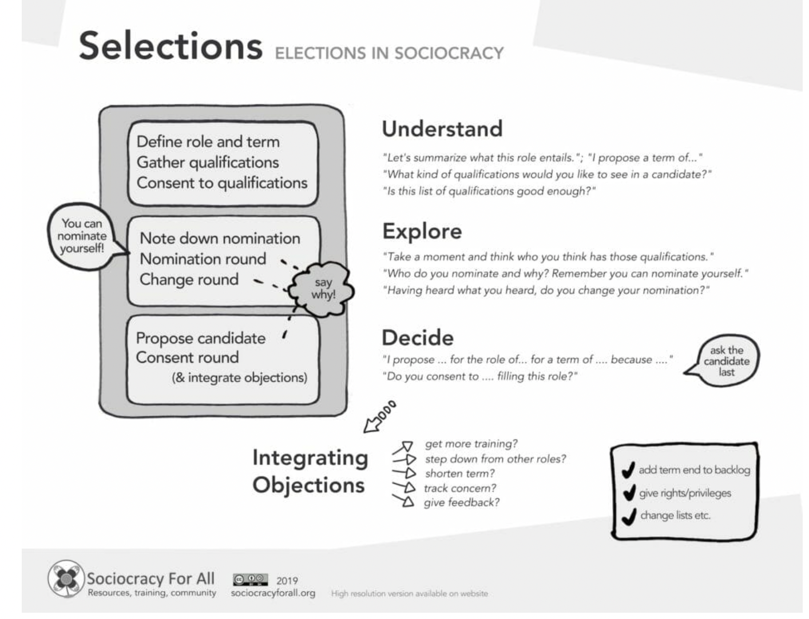

Feedback
Feedback is prioritised in many ways in Sociocracy: meeting evaluations, role improvement and policy evaluations are some of the examples. Regular 1:1 support meetings and performance reviews for staff, plus buddying for volunteers, are ways that we currently seek to incorporate personal feedback.
Feedback is valuable data: it tells us both what is working well and also what needs adjustment. In challenging and emotionally difficult times, shifting from a frame of criticism to a frame of constructiveness and curiosity means we can learn from each other and from the data we observe or measure. Over time, we can evolve, grow, self-repair and get better at supporting each other … if we can build trust so as to be able to give and receive feedback.

Transparency
Sociocracy is not only a way of working together, it helps reduce inequality through transparency. We work openly. Everyone should have access to all relevant information. Salaries and freelance rates are open and transparent. Meeting minutes and budgets are accessible to all members of all circles unless relating to personal / confidential (e.g. HR) information.

Circle Membership
We depend on members of ELCAN contributing to the running of the network through joining one of our circles. Our circle structure creates many niches for members to get involved in strategic decisions as well as operational tasks, depending on their skills, interests and time available. Circle membership requires a certain level of commitment which needs to be made clear before joining. Existing circle members must give their consent to new circle members joining.

Routine Processes for Meetings
See more on Sociocratic Meeting Format (from Sociocracy for All)
In Sociocracy, there are two basic frames for decision making:
- Operational Decisions
- Policy Decisions
Operations are tasks performed to deliver on the circle’s purpose, often outside of a meeting and by anyone to whom the circle has given authority to make that decision. Operational decisions are case-by-case decisions, interpreting the purpose and policy and making choices to complete the task.
Policy decisions are made to frame, guide and support operations and are made by the circle for itself, by consent of all circle members.

 | Operational Decisions | Policy Decisions
Basis | Current policy | Previous policy; new needs
Made by | Circle members/roles | The Circle, by consent
Scope | Case by case basis | Long-term
Some circles are operations-heavy whilst others are policy-heavy (e.g. General Circle).

Record Keeping
Each Circle must maintain a meeting log, in the circle’s folder in ELCAN’s shared GoogleDrive, with a record of membership of the Circle, meeting agendas and notes, a current list of outstanding actions, a logbook of consented proposals and review dates plus a link to the Circle’s current work-plan. For transparency, this document’s sharing settings should make it accessible to all members of all circles (with the exception of confidential e.g. personal HR information, which may require sharing to be restricted).

Checking in at the start of a meeting
At the start, before any agenda item, everyone in the group “checks in” by briefly saying how they are doing/feeling. “What do I need to say to be fully present in the meeting?” This is so that we can share what is affecting us (tired / distracted / buzzing) so that we can be honest in how we are and can then contribute as best we can and so that, by sharing a bit about ourselves, we get to know each other and can work better together as our ‘whole selves’.

Consent to the Agenda
A week before each meeting, the Facilitator – with input from the Lead Link – should prepare a draft agenda (with estimated timings) and circulate it to circle members for their comment and input. At the start of the meeting, the Facilitator presents the agenda and asks for comments, any other business and the circle’s consent to a final meeting agenda.
Because what is and is not being talked about – and decided on – involves power, the Facilitator pays attention to what needs to be talked about; but ultimately, participants decide on the agenda. That way, equivalence and transparency can be supported in making decisions on what is relevant to spend time on and how much time is devoted to each item.
For efficient meetings, it is important to be clear about the category of any particular agenda item:
There are three distinct categories of agenda items:
- Reports
- Explorations
- Decisions

Using Rounds to draw people in
To encourage all voices much of the meeting process is done by going round the participants to hear their contribution. The Facilitator might choose one person in the circle to start – and that person then chooses who to pass to. People don’t interrupt or cross-talk, and each tries to be concise, to not wander from the point in hand and not to repeat what others have already said.
Rounds are simple and yet powerful: everyone gets to speak; and all get a chance to listen. You move gently as a group, like a flock of birds, always knowing where other group members are at. People who feel truly heard do not have to repeat themselves.

Proposals for decision
Proposals can be brought to a meeting by an individual, a circle or generated in a collaborative way during a meeting using a process called picture forming. This proposal template (make a copy before completing it) should be used where possible.
Any proposal should start with a clear statement that explains the issues it is trying to resolve: the situation, its effect on ELCAN and ELCAN’s needs. Good decisions on proposed actions or policy are based on research, are supported by everyone in the group, incorporate input which responds to objections, cover all the relevant issues, specify a term after which they will be reviewed and a performance indicator for measuring their effectiveness wherever possible.
Collaborative (consent) decisions maximise buy-in, accountability and information sharing. Evaluating such decisions periodically enables members of an organisation to dynamically adjust their policies according to the feedback that they measure and thus ensure they fulfil their purpose. See more on developing proposals here.

Understand, Explore, Decide
The ‘Understand, Explore, Decide’ cycle is fundamental to the sociocratic process for any discussion. For example, to collaboratively generate a proposal, every member of the group must first understand the context and the issue that needs to be addressed so that they can then collectively explore ideas for addressing the issue (and this is where a diverse group who each bring different experience and perspectives can be really helpful) and then go on to synthesise and decide an agreed proposal. By separating out these steps, much more focussed, efficient, effective and creative collaboration becomes possible.

Consent process in rounds
It is crucial to understand that we are not aiming for ‘consensus’, in which everyone is in full agreement with all decisions. Instead, we are aiming for ‘consent’ i.e. for decisions that everyone can live with or tolerate, even if they don't align with their personal preference.
The consent process has five parts:
- Opening presentation by the proposer or by the Facilitator
- Clarifying questions round (to ensure that everyone fully understands the proposal)
- Reactions round(s) (to explore everyone’s responses)
- Objection round to decide if the proposal conflicts with the purpose of the circle / ELCAN
- Consent round to confirm agreement by all for a “good enough for now and safe enough to try” decision.
Each part of the process contributes to equivalence, effectiveness and transparency, which are the guiding principles of Sociocracy. Instead of jumping straight to hearing people’s opinions, we first try to understand the context and what the proposal actually is. In the reactions round (or rounds), we get a sense of where the group is at. Sometimes several rounds will be helpful as people build on what they have heard. It is also the place for small “tuning” improvements that are in line with the proposal. Consent decisions ensure equivalence: a decision is made only when no one has an objection.

Objections to Proposals
Objections are concerns in response to a proposal. In Sociocracy, objections are seen as gifts to the group which ensure the best possible outcome. As such, and contrary to many groups’ normal practice, objections are actively encouraged.
Objections should be made when: “carrying out this proposal is against the purpose of this circle / ELCAN or would interfere with my being able to do my work”. Assuming everyone wants to work effectively, objections are valuable input. For that reason, we want a way to incorporate that information into the proposal. More on objections.

Range of tolerance
We generally try to use a test: “Will consent to this Proposal assist the purpose of this Circle / ELCAN – or does it conflict with that purpose?” “Range of tolerance” is a concept that differentiates between personal preference / what I really want to happen and what I am able to work with. Is this proposal “good enough for now and safe enough to try?”
Too often, we get caught up in personal preferences. To be truly collaborative and effective in our decision-making, we widen our options by not going for everyone’s preference but only for their range of tolerance. That way, we can find common ground more easily and avoid getting stuck.
By agreeing a term after which the decision will be reviewed, circle members can feel safe that any concerns that they have will be revealed by feedback gathered from trying out the proposal in practice.
In the event that a proposal is not consented, the options for achieving consent are:
- To shorten the term so that the proposal will be revisited sooner
- To ‘measure the concern’, that is to put in place a way of measuring the actual impact of the proposal in practice (instead of speculating about the risk of what might happen)
- To modify the proposal so as to integrate the objection (this may require further work to develop a modified proposal to be brought to a future meeting)

Meeting evaluation
Meeting evaluations/check-outs or ‘reflection rounds’ are a simple process: at the end of every meeting, we evaluate how the meeting went. “What went well and what could have been better?”
Too many organisations are stuck in the same ways. Establishing simple, small feedback loops (“how are our meetings working for us?”) should increase each circle’s effectiveness over time.
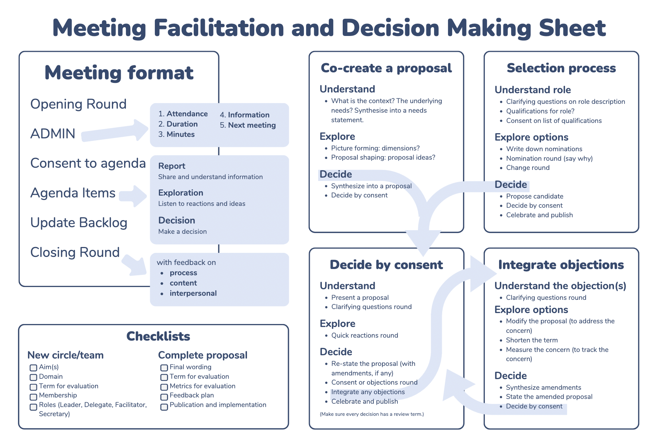

Internal Communications
ELCAN’s Google Workspace is where all shared files are stored. Each Circle has a folder within the main ELCAN Shared Drive and all circle members should be given access to this folder by their Lead Link or Secretary.

Created: 1 March 2026
Approved: 1 March 2026
Next Review Date: 1 September 2026

